AFRL Quarterly Report (November 1, 2008 – January 31, 2009)
Task 2: Self Repair of Space Structures
PI: Umesh A. Korde

Background Based on Previous Reports

The objective of this task is to investigate novel technology for automatic self-repair of thin lightweight space structures. An ability to self-repair minor damage caused by collisions with micrometeors and space debris would help keep the structure from losing its functionality. We propose here to investigate a novel method for structural self-repair based on acoustic energy. The proposed technique represents a significant advancement over the state of the art in allowing quick detection of incipient damage such as a crack and timely sealing at the site of inception. The proposed work will also consider depletive defects other than cracks, such as dents and peel offs.

Goals for Year 1 (August 4, 2006 – July 31, 2007)

- Deliver a detailed literature review of the state of the art.
- Deliver an analytical model for time reversed acoustic focusing.
- Deliver test results with focusing.
- Deliver an investigation of available acoustically activated polymers (MSU).

Goals for Year 2 (August 1, 2007 – July 31, 2008)

- Deliver additional test results.
- Deliver a time reversal algorithm with acoustically activated polymer resins (AAPR).
- Deliver a preliminary finite element model of acoustic self-repair.
- Deliver preliminary test results on repair using acoustic focusing and AAPR.

Goals for Year 3 (August 1, 2008 – July 31, 2009)

Continue work on the above to extend and enhance the deliverables.

Goals for Report Period (November 1, 2008– January 31, 2009)

- Continue progress on literature review of wave propagation on thin structures and time reversal.
- Continue new developments on analytical modeling of wave propagation with and without crack.
- Continue experimental testing of wave propagation and time reversal, and continue animation studies of time reversal.

I and II. Continue literature review of the state of the art and new developments in analytical modeling

As mentioned in our previous report, at this point, there seem to be two essential points to establish in this project: (i) the effect of acoustic excitation on the healing tendency of polymers, and (ii) the effect of focused acoustic excitation on healing. The focus this quarter has been on the experimental work, first the experimental testing of wave propagation and time reversal, and next, the tests on epoxy-curing without and with acoustic excitation. Wave propagation tests were carried out on curing epoxy, to investigate the efficiency of wave propagation at various stages of curing.

III (a). Experimental work on time reversal (Fehrman)

Currently, multiple approaches are being taken in order to find the best combination of software and hardware for time reversal implementation. The software and hardware must be able to handle the requirements of very high speed sampling with a certain amount of accuracy, as well as being capable of playback with the same speed and accuracy.

One approach is using the FPGA system that we are currently using for the Fast-Steering Deformable Mirror project (Figure 1). The hardware is theoretically capable of achieving the speeds that are needed for the self-healing project. This system also allows us a high level of determinism when it comes to the actual program execution. Preliminary test are showing that this may be suitable for the project. The tests include reading a frequency on two channels, storing the data points, then playing back the frequency. Although we have not immediately seen this to be reliable for higher speeds, we feel that it is very possible and that further research will result in a solution to attain the higher speeds. The one drawback to this system is that it is not as flexible as our other option that we are currently looking into.

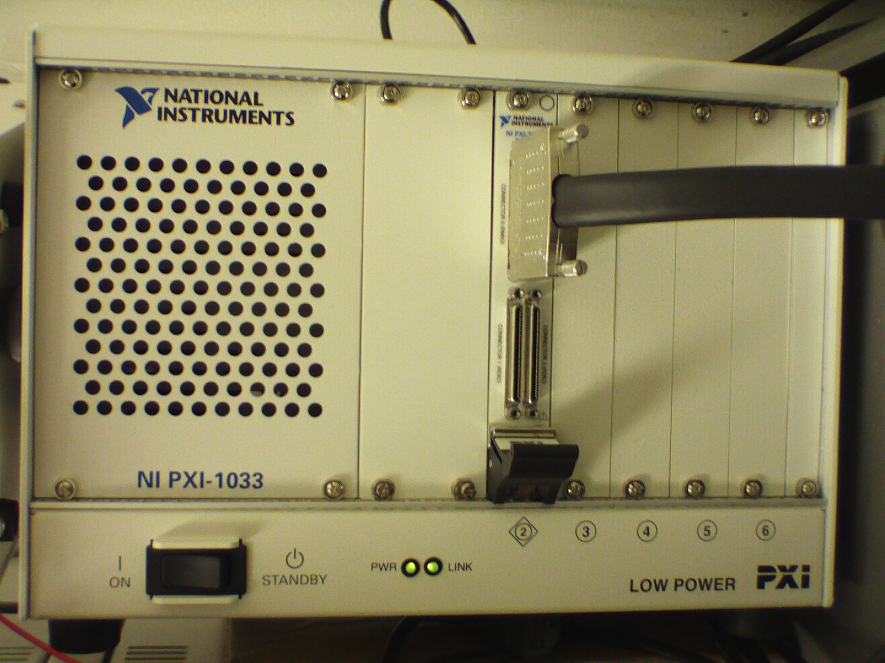

Figure 1: FPGA System (Chassis with FPGA card installed)

The second approach we are taking is to implement a different National Instruments DAQ card. This card will be run in the real-time system that we have tried previously for the Fast-Steering Deformable Mirror project. Although the real-time system was found to not be suitable for the Mirror project, we feel that it will work acceptably for the Self-Healing project since we are allowed to buffer the input instead of taking and processing the data point by point. The real-time system will have a dual-core processor. This will allow for us to retrieve data from the DAQ card’s buffer with one core while processing the data with the other core. The same is true for outputting the data. We are able to write data to the DAQ card’s buffer with one core while performing any other operations with the other core. We are currently testing an older DAQ card that we have on hand in order to prove the principle that it will work with a newer card. The benefit of using this method over the other is that it provides an immense amount of flexibility when it comes to programming and testing the card.

For future work, we plan to continue testing both methods until we determine which one is more suited for solving the problem. If neither method results in a usable solution, we may revert back to testing a previous card from a different vendor that was somewhat less desirable in the programming aspects but may be able to produce good results. Other possibilities are also available, such as using two oscilloscopes and four AWGs to produce the signals, store the signals, and then play back the signals.
III (b). Experimental work on acoustic healing (wave propagation in curing epoxy) (Barnes)

There are useful insights to be had from the results below. In particular, it does not appear that the transducers couple well to the liquid/uncured epoxy. The inability to obtain a pure sinusoidal record at the receiving end may suggest that the air bubbles within the epoxy play a more prominent role prior to curing. The effect of the air bubbles reduces as the epoxy cures, due to the better impedance match between the transducers and the solid epoxy. This highlights the need for careful degassing soon after mixing, as well as the need to choose the piezoelectric transducers with care.

Current Tests

The brass tubes have a calculated natural frequency of 100KHz. Using a piezo ceramic transducer, an AWG fed signals of 95-115 KHz to one end while the oscilloscope received with a piezo ceramic transducer at the other end of the tube. Tests were conducted using freshly mixed epoxy, partially cured epoxy, and fully cured epoxy. Cured epoxy was found to produce significantly more defined wave patterns. The partially cured epoxy was monitored three hours after mixing, thus giving the epoxy full set time at one hour and two additional hours of cure time. Graphs for 95KHz, 100KHz, and 115 KHz are provided for each stage: freshly mixed, partially cured, and fully cured. The horizontal axis shows the time coordinate, while the vertical axis plots the receiving-transducer measurement.

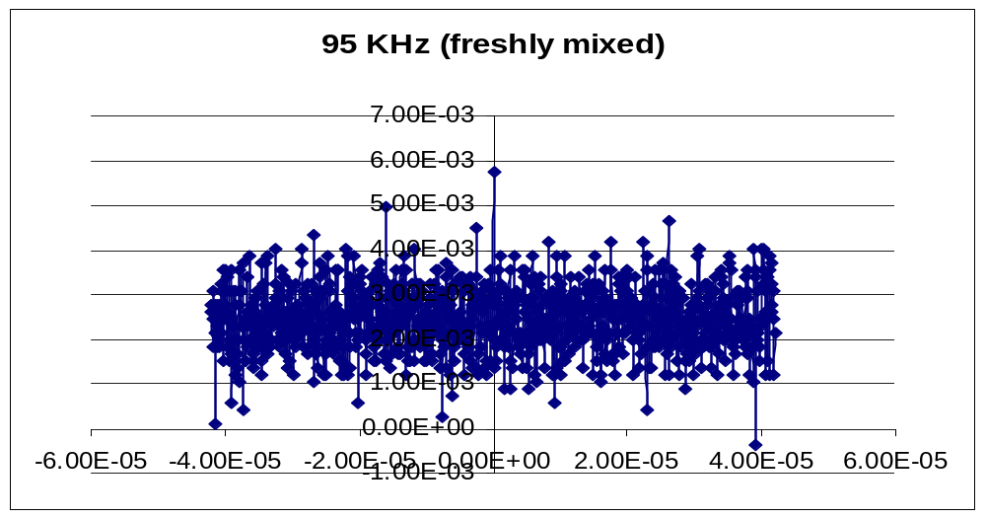
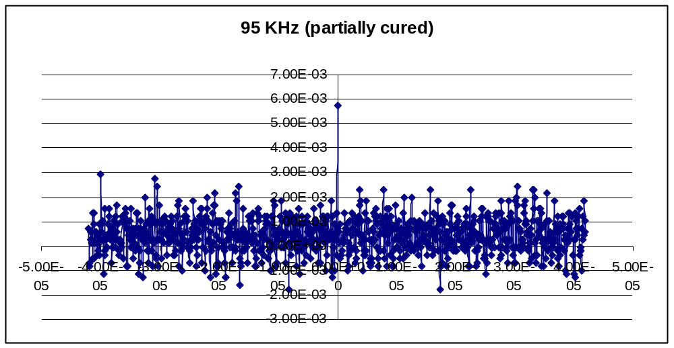

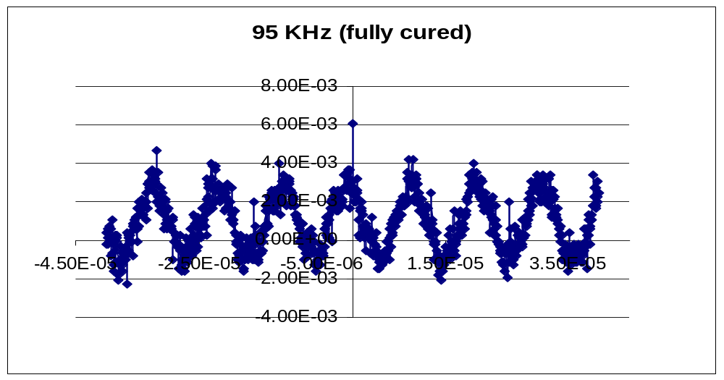

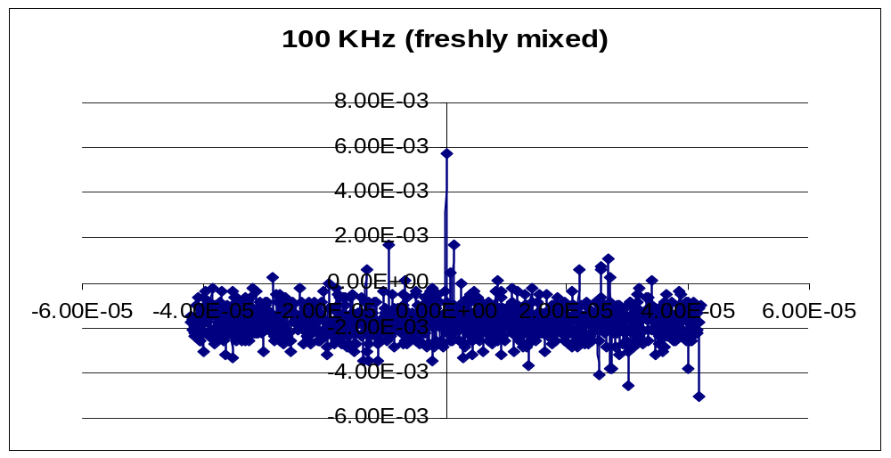

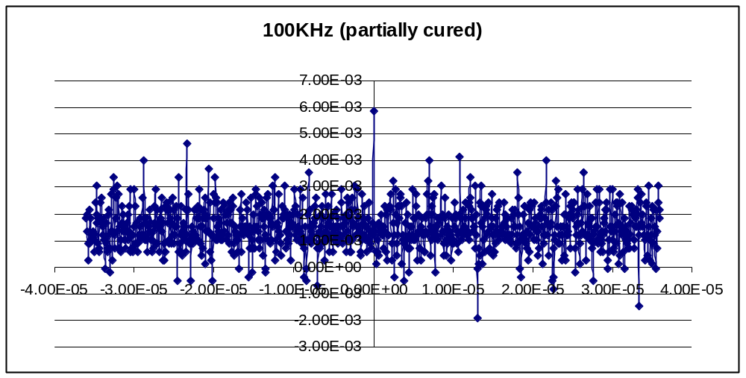

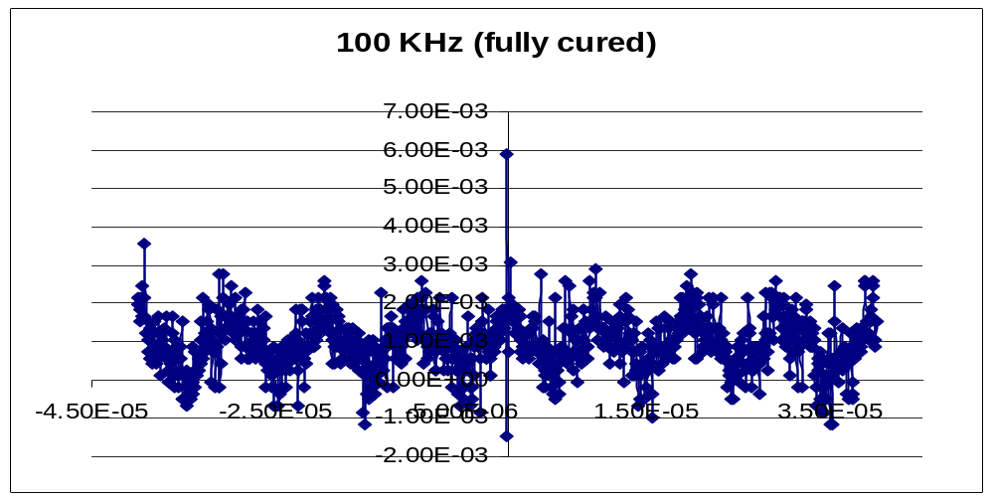

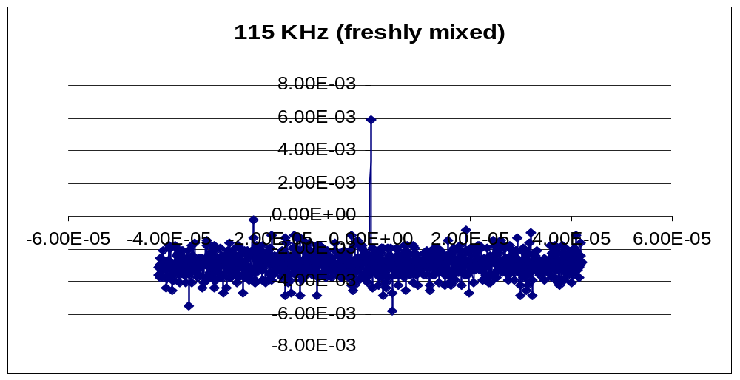

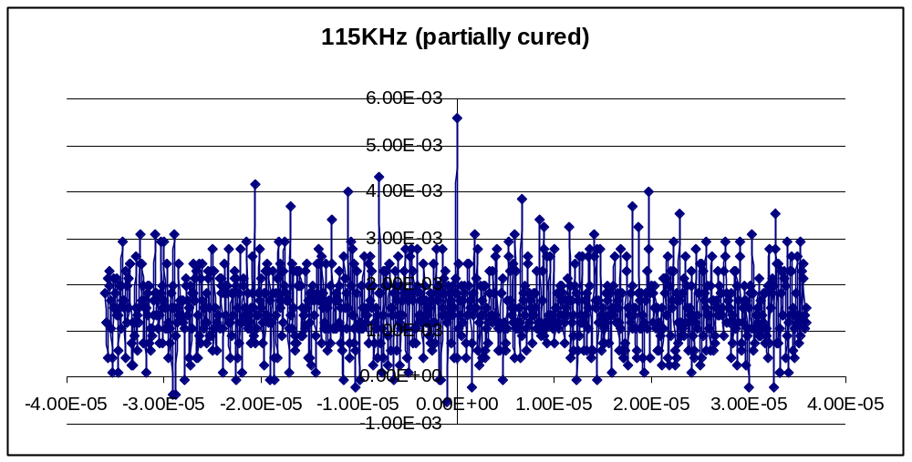

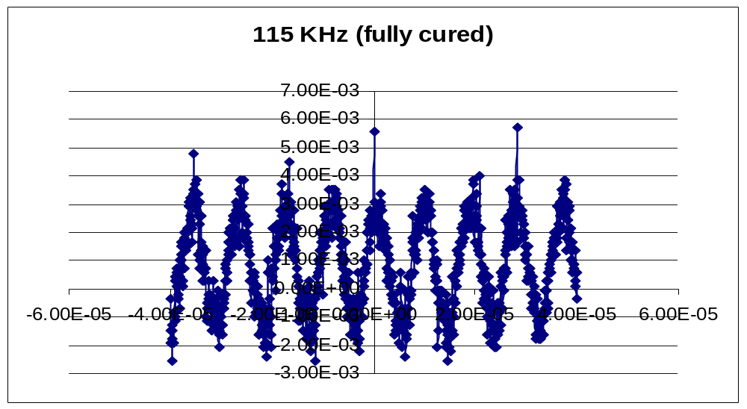

Planned Work

During a meeting with Dr. Robb Winter, we discussed many ideas for future work. Dr. Winter suggested we degas the epoxy after mixing, by sealing a glass beaker and using a vacuum pump for a set time, such as ten minutes. This will ensure consistency among testing and ensure the bubbles have been removed from the epoxy. Dr. Winter also suggested we find a way to view the temperature peaks in relation to the nodes and antinodes. This could be accomplished by using an IR camera. Additional information could be obtained about the epoxy curing process if the epoxy was placed in a beaker with a known volume and a mass of known volume was also placed in the beaker. As the curing process occurred, we would be able to monitor the mass in the epoxy and the changes occurring to find the density over the cure. A final suggestion for future work was to maintain nodes and antinodes by feedback.

Goals for Project Period February 1, 2009 – April 30, 2009

  - Continue progress on literature review of wave propagation on thin structures and time reversal.
  - Continue new developments on analytical modeling of wave propagation with and without crack.
  - Continue experimental testing of wave propagation and time reversal, and continue animation studies of time reversal.

Students supported during report period

- Katherine Barnes, ME undergraduate student
- Brian Fehrman, Computer Science undergraduate student
- Jon Fisher, BME graduate student

Publications during report period

A journal paper based on the method reported above is currently under preparation.

